**Database Practice Exercise:**

**1.Create Database:**

In order to create a database we use the command : create DATABASE databasename;

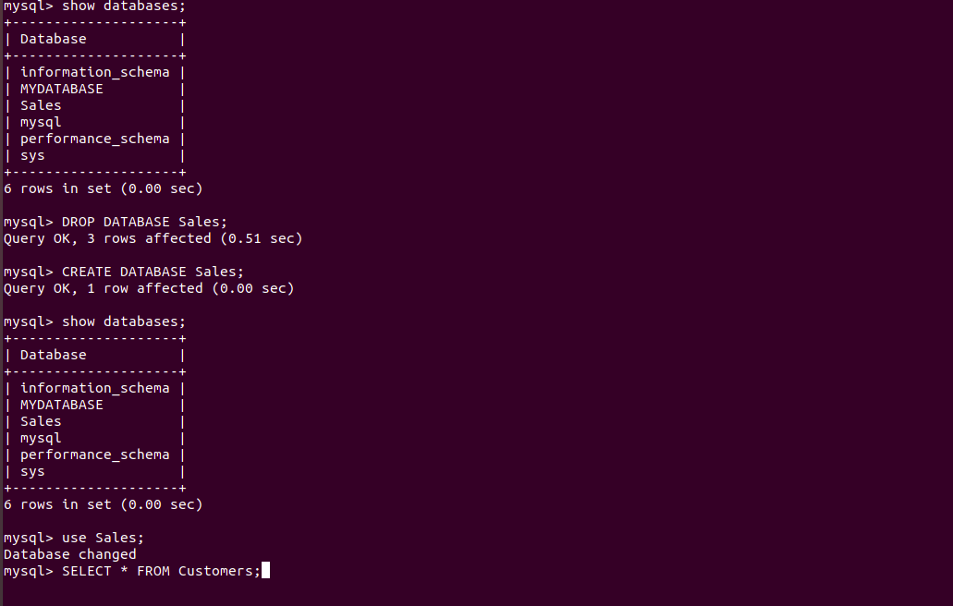

**2.Design Schema:**

Scheme defines the structure of the database.

We can do that using desc command.

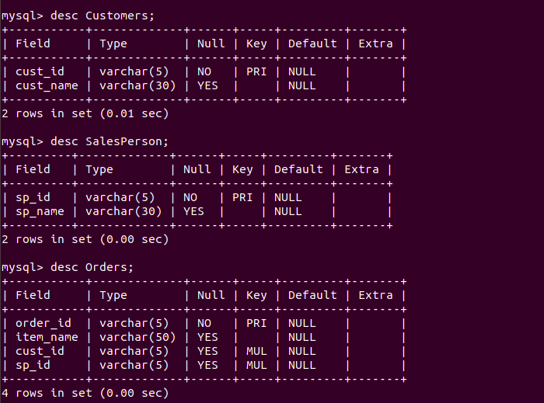

**3.Create tables:**

In order to create a table we perform :

-> use Database;

-> create table TableName;

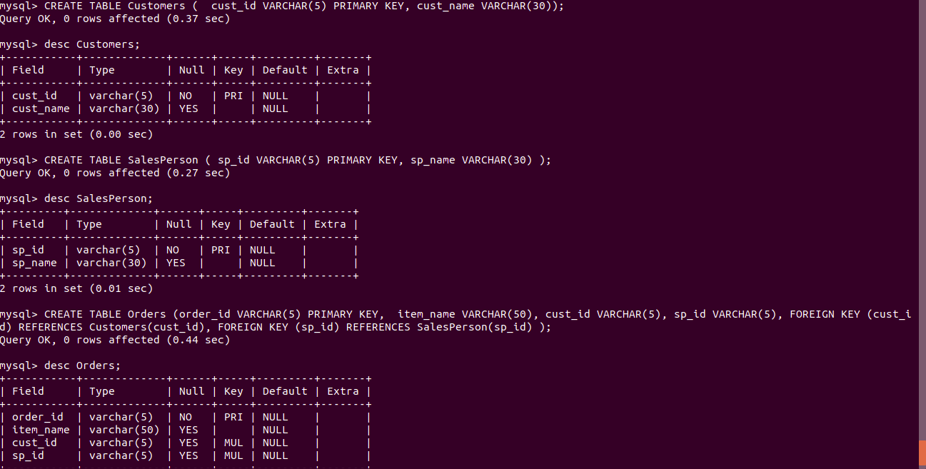

**4.Insert sample data.**

In order to insert data in tables: we perform insert into tablename values(specific values);

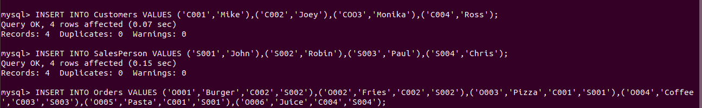

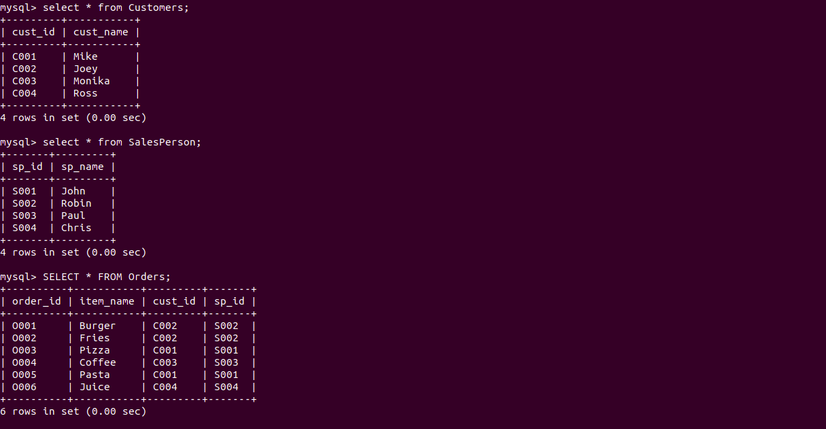

**5.Find the sales person have multiple orders.**

In this case, we are using join in order to extract data from two tables. We first use left join on the condition where SalesPerson sp_id == Orders.sp_id;

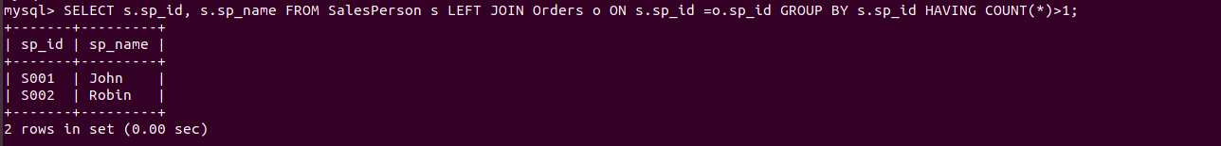

**6.Find the all sales person details along with order details.**

Again, using join we will get all the required data.

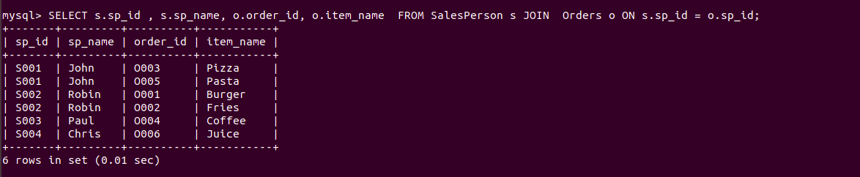

**7 & 8.Create index and How to show index on a table**

To make search operation faster we can perform indexing that allows extraction of data faster and easier.

To create index we perform create index indexname on Tablename(attribute_name);

To show an index do: show indexes from tablename;

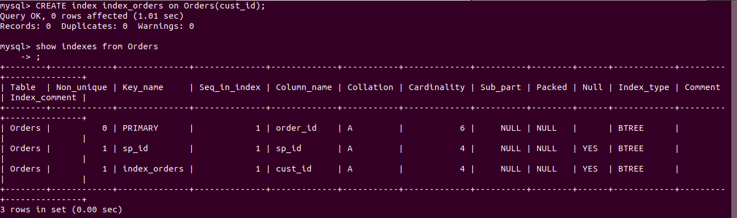

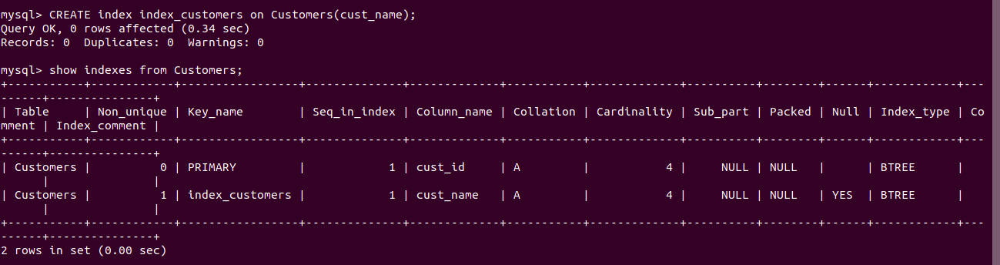

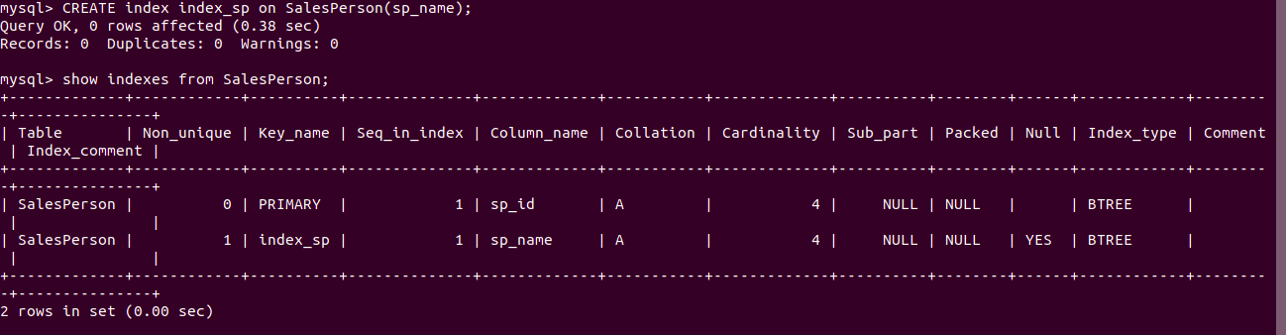

**9.Find the order number, sale person name, along with the customer to whom that order belongs to.**

Firstly, we select order_id, sp_name, cust_name from all the 3 tables by joining them altogether.

